**Student Name: Rishav Kumar UID: 22MCC20039 Section/Group: 22MCD-1 (A) Semester: 2nd**

**Branch: MCA-CC &DevOps Date of Submission: 12-05-2023**

**Subject: Advanced Internet Programming Lab Subject Code: 22CAP-686**

**Experiment No. 8**

Write the database operations as Insert, delete, update, search operation in Hibernate

1. **Aim/Overview of the practical:**

Perform CRUD operation with the help of Hibernate.

**Task to be done:**

Perform CRUD operation with the help of Hibernate.

1. **Algorithm/Flowchart :**

**Step 1:** Create one java application with name Exp1.

**Step 2:** Now right click on source package>>new>>others and then select hibernate and select hibernate configuration wizard and select database and click on finish.

**Step 3**: Right click on default package>>new>>others and then select hibernate and select hibernate reverse engineering wizard. Then select available table employee and click on add.

**Step 4:** Right click on source package>>new>>java package (with name POJO).

**Step 5:** Now right click on POJO>>new>>other and then click on hibernate and select hibernate mapping files and POJO’s from database.

**Step 6:** Create one more package with name connection. right click on connection>>new>>other and then click on hibernate and select HibernateUtil.java.

**Step 7:** Now create one java application to perform CRUD operations.

1. **Code for experiment/practical:**

package connection;

import POJO.Employee;

import java.util.Scanner;

import org.hibernate.Session;

import org.hibernate.Transaction;

/**

*

* author Anshul

*/

public class EmployeeDB {

public static void insert(Session session,Transaction tx,int Id,String Name,Integer Salary){

Employee e=new Employee();

e.setEmpId(Id);

e.setEmpName(Name);

e.setEmpSalary(Salary);

tx=session.beginTransaction();

session.save(e);

tx.commit();

System.out.println("Object inserted successfully.");

}

public static void update(Session session,Transaction tx, int updateId,String newName,Integer Salary){

tx=session.beginTransaction();

Employee e =(Employee) session.get(Employee.class, updateId);

if (e != null) {

e.setEmpName(newName);

e.setEmpSalary(Salary);

session.update(e);

tx.commit();

System.out.println("Object updated successfully.");

}

else {

System.out.println("Object not found.");

}

}

public static void delete(Session session, Transaction tx, int id){

tx=session.beginTransaction();

Employee e=(Employee) session.get(Employee.class, id);

if(e != null) {

session.delete(e);

tx.commit();

System.out.println("Object deleted successfully.");

} else {

System.out.println("Object not found.");

}

}

public static void read(Session session,int id){

Employee e=(Employee)session.get(Employee.class,id);

System.out.print("Employee Id :" + e.getEmpId() + "\n");

System.out.print("Employee Name :" + e.getEmpName() + "\n");

System.out.print("Employee Salary:" + e.getEmpSalary() + "\n");

}

public static void main(String[] args){

Scanner scanner = new Scanner(System.in);

Transaction tx = null;

Session session = null;

try {

session = Controller.getSessionFactory().openSession();

while (true) {

System.out.println("1. Update");

System.out.println("2. Insert");

System.out.println("3. Delete");

System.out.println("4. Read");

System.out.println("5. Exit");

System.out.print("Enter your choice: ");

int choice = scanner.nextInt();

switch (choice) {

case 1:

System.out.print("Enter the id of the object to update: ");

int updateId = scanner.nextInt();

scanner.nextLine();

System.out.print("Enter the new name: ");

String newName = scanner.next();

System.out.print("Enter Employee Salary: ");

int salary=Integer.parseInt(scanner.next());

update(session, tx, updateId, newName,salary);

break;

case 2:

System.out.println("Enter the details: ");

System.out.println("Enter Employee Id: ");

int Id = scanner.nextInt();

System.out.println("Enter Employee Name: ");

String name = scanner.next();

System.out.print("Enter Employee Salary: ");

int sal=Integer.parseInt(scanner.next());

insert(session, tx,Id,name,sal);

break;

case 3:

System.out.print("Enter the id of the object to delete: ");

int deleteId = scanner.nextInt();

delete(session, tx, deleteId);

break;

case 4:

System.out.print("Search details:/n");

System.out.println("Enter Employee Id: ");

int id = scanner.nextInt();

read(session,id);

break;

case 5:

System.out.println("Exiting program.");

return;

default:

System.out.println("Invalid choice. Please try again.");

break;

}

}

} catch (Exception e) {

e.printStackTrace();

} finally {

session.close();

}

}

}

1. **Result/Output/Writing Summary:**

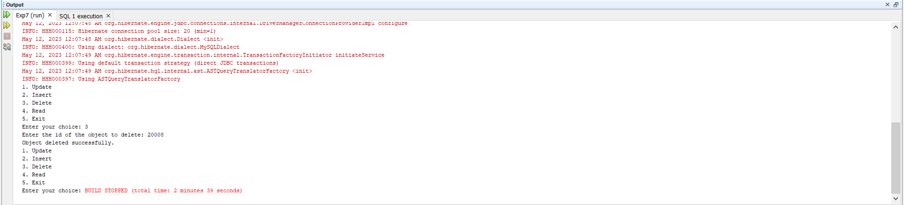

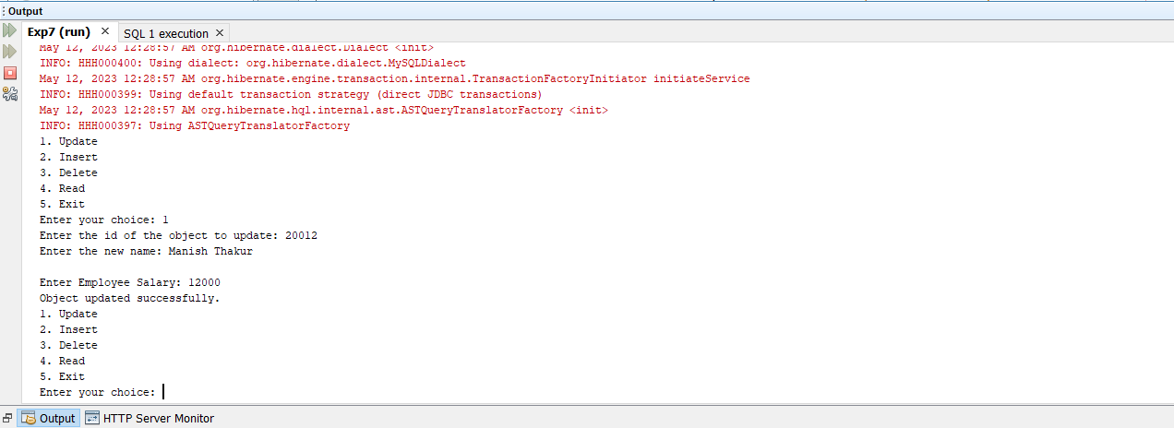

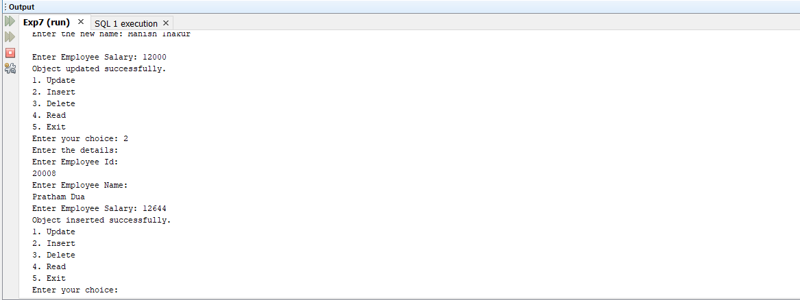

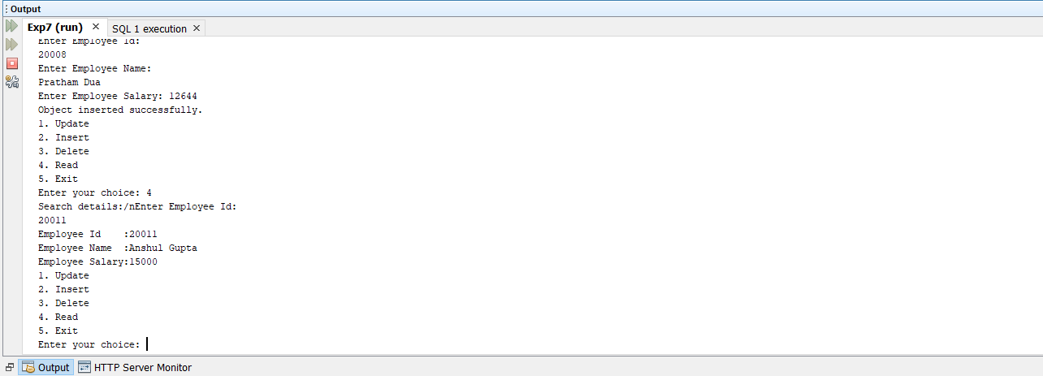

**Learning outcomes:**

**1.** Learn to perform CRUD operation in Hibernate.

**2.** Learn to implement Hibernate.